

**Mawlana Bhashani Science & Technology University**

**Lab Report No : 02**

**Course Code : ICT-3106**

**Course Title : Microprocessor and Assembly Language Lab**

**Submitted by Submitted to**

**Name : Maskur Al Shal Sabil S.M. Shamim**

**Id: IT18021 Lecturer**

**3rd year 1st semester Dept of ICT,**

**Session : 2017-2018 MBSTU**

**Dept of ICT**

**MBSTU**

1(a) Read a character and display it at the next position on the same line

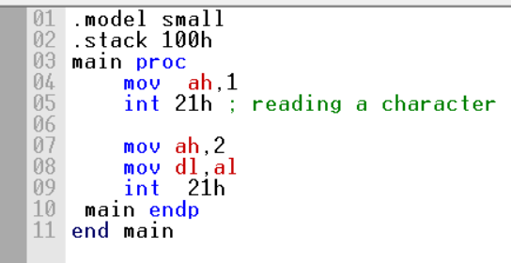

Output :

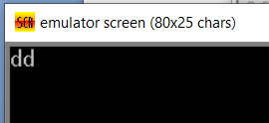

1(b) b. Read an uppercase letter and display it at the next position on the same line in lower

Case

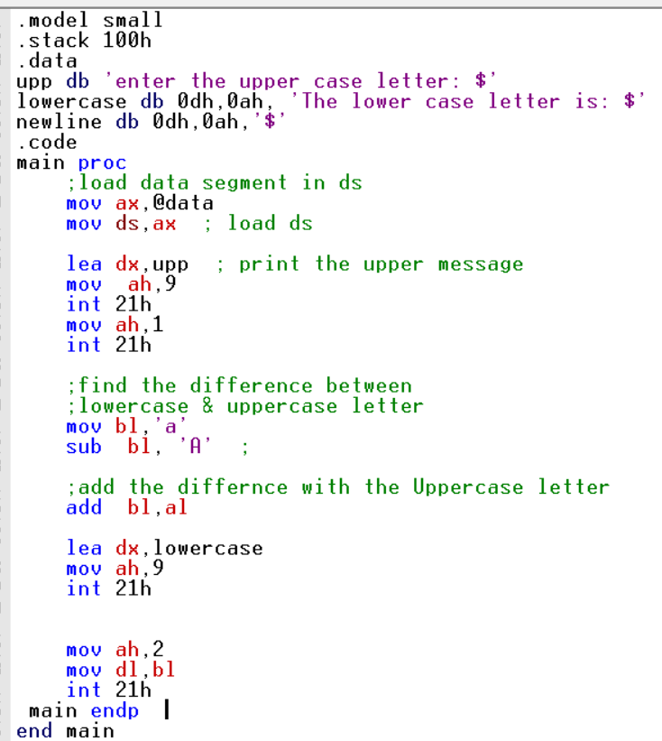

Output:

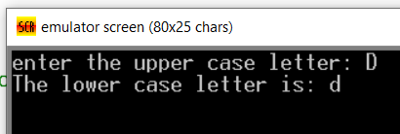

2(a) . display a “?”

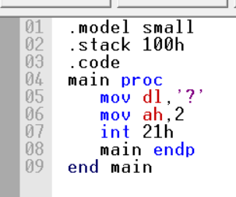

Output:

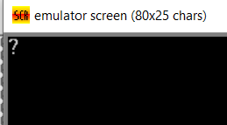

2(b) read two decimal digits whose sum is less than 10

c. display them and their sum in the next line with an appropriate message.

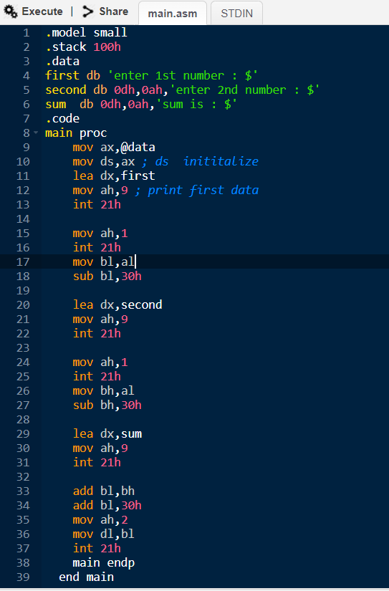

**Output:**

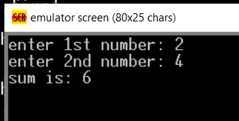

**3. write a program to**

**a. prompt the user**

**b. Read first middle and last initials of a person’s name**

**c. And display them down the left margin**

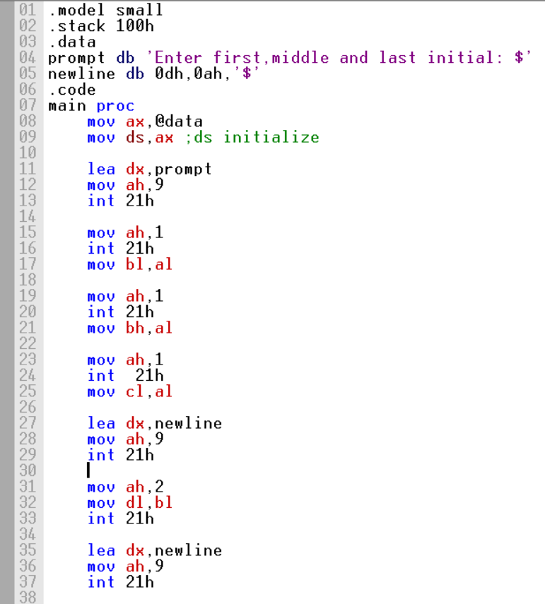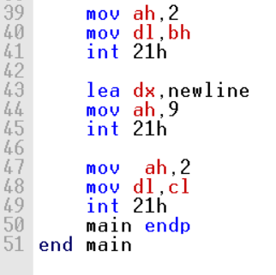

**Output:**

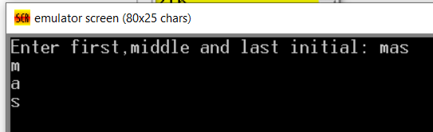

**4. Write an assembly program to enter one of the hex digits A-F, and display it on the next line in decimal.**

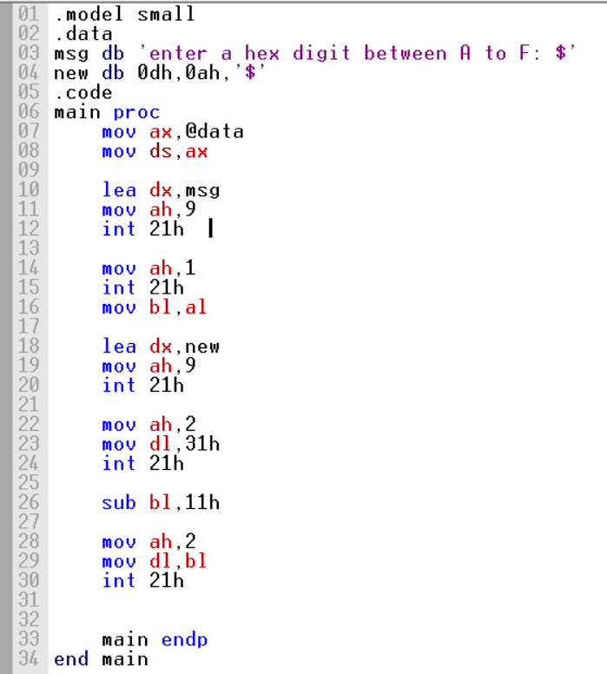

**Output:**

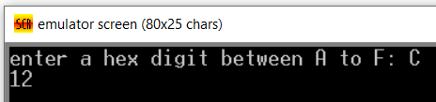

**5. Write an assembly program to display asterisks (***********) ten times with new line.**

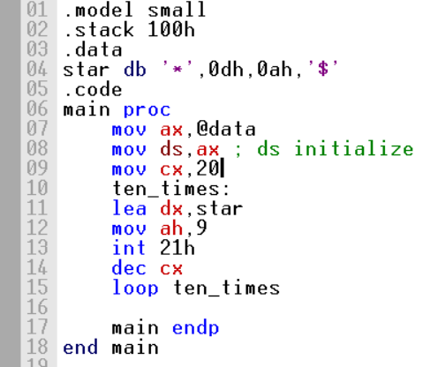

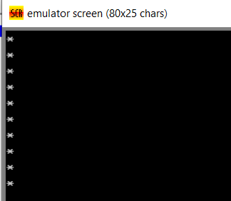

**6. Write an assembly program to display to (a) display"?", (b) read three initials,(a,b,c) display them in the middle of an 11 x 11 box of asterisk**

|  |  |  |  |  |  |  |  |  |  |  |
| --- | --- | --- | --- | --- | --- | --- | --- | --- | --- | --- |
|  |  |  |  |  |  |  |  |  |  |  |
|  |  |  |  |  |  |  |  |  |  |  |
|  |  |  |  |  |  |  |  |  |  |  |
|  |  |  |  |  |  |  |  |  |  |  |
|  |  |  |  |  |  |  |  |  |  |  |
|  |  |  |  |  |  |  |  |  |  |  |
|  |  |  |  |  |  |  |  |  |  |  |
|  |  |  |  |  |  |  |  |  |  |  |
|  |  |  |  |  |  |  |  |  |  |  |
|  |  |  |  |  |  |  |  |  |  |  |
|  |  |  |  |  |  |  |  |  |  |  |

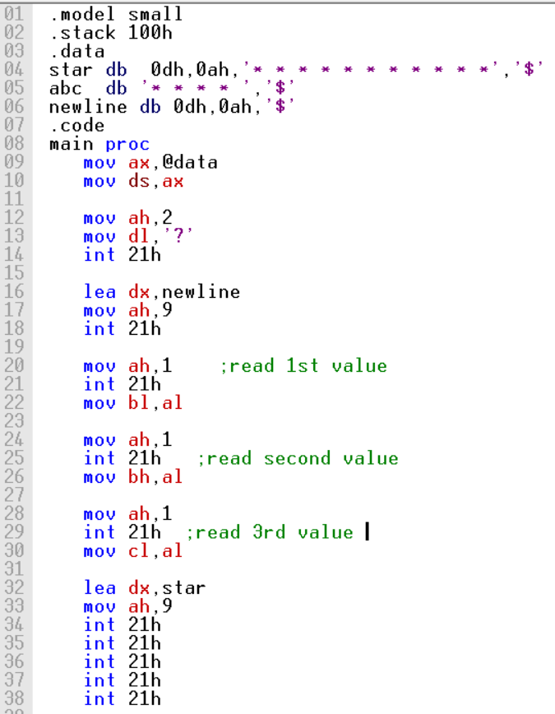

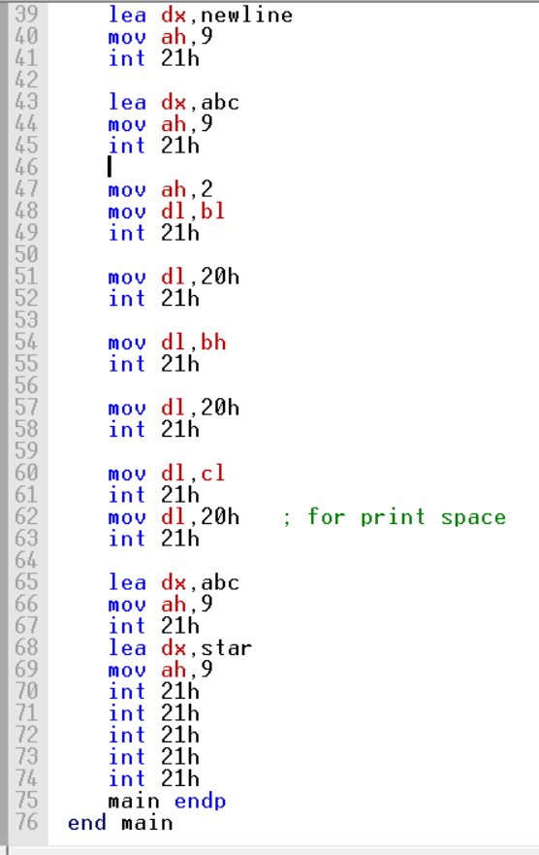

**Output:**

